**DML STATEMENT USING SIMPLE RETAIL SYSTEM**

**1. Create Tables**

Firstly, creating the tables suppliers, products, and orders. Each table includes primary keys, foreign keys, and constraints like NOT NULL and DEFAULT.

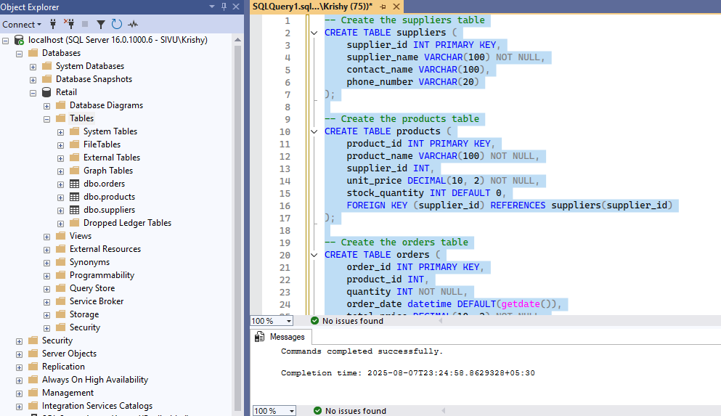

**2. Insert values**

**Adding Values**

Adding the first value of Supplier table where we provided all the column values without skipping it.

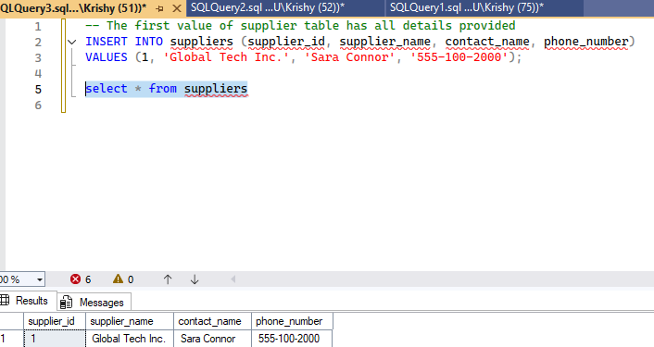

**Null values**

Skipping contact_name and Ph.no of Supplier table which will be stored as NULL.

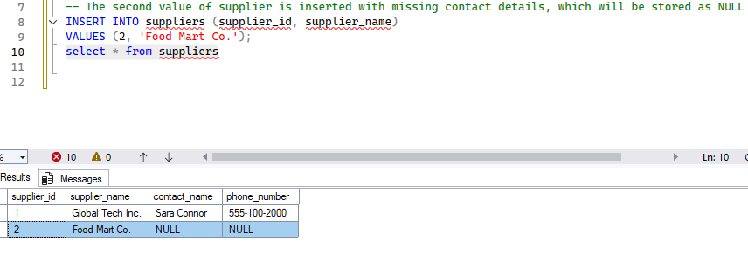

**Handling Defau1t values**

We explicitly provided the first value of Product table .

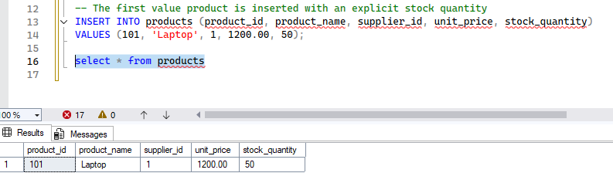

We skipped the value of stock_quantity of the product resulted 0 as we used DEFAULT constraints.

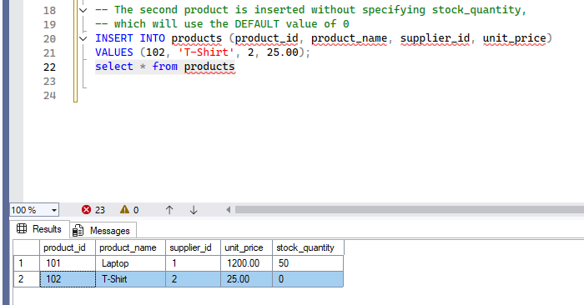

**3. UPDATE and DELETE with WHERE Conditions**

Modifying and removing data using WHERE clauses to ensure changes are applied to the correct records.

**UPDATE Statements**

Update the unit price of a specific product.

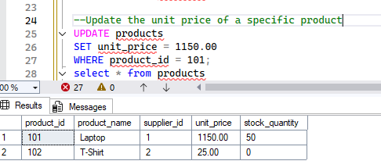

Update the stock quantity and supplier for a product

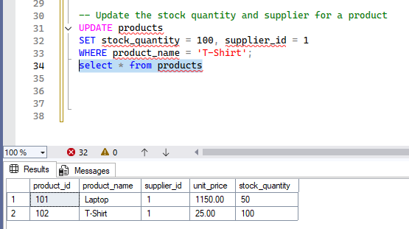

Replacing the null values for supplier tables.

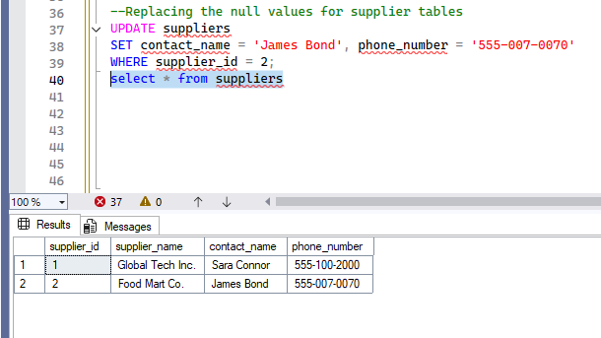

**DELETE Statements**

Delete a specific order

Before Deleting

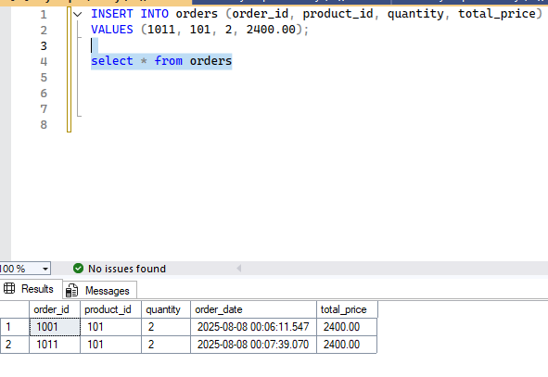

After deleting

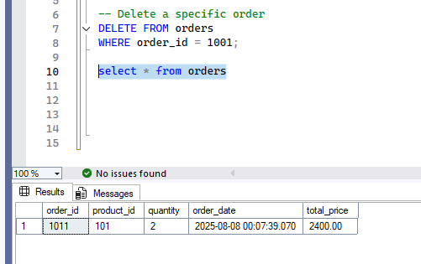

Delete a product that is no longer sold

Before deleting

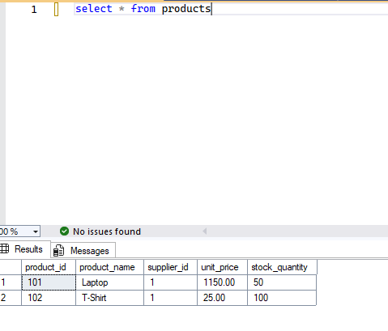

After deleting

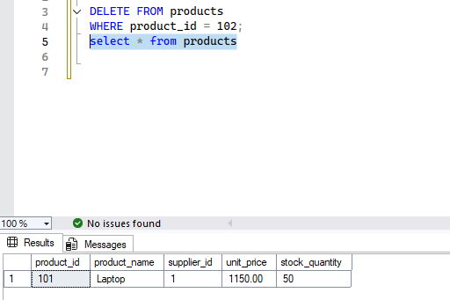

Delete a supplier (this may fail if there are foreign key constraints from other tables that still reference it, so we delete products first if needed).

Before Deleting

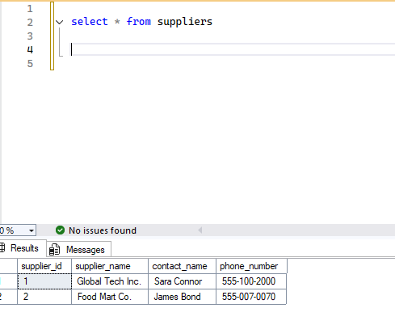

After deleting

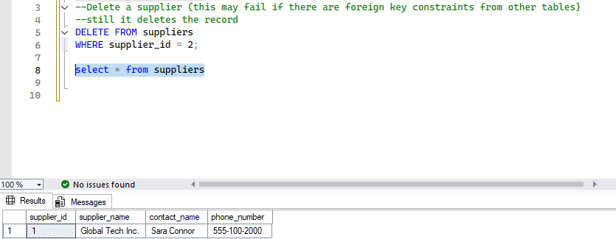

Thank you!